📘 Guru99 PROJECT REPORT
Automation Testing of Banking Application (Guru99 Demo V4)
URL: https://demo.guru99.com/V4/

1. Project Overview
This project is designed to automate end-to-end functional testing of a banking web application using Selenium WebDriver with Java and TestNG. The framework ensures comprehensive validation of all critical banking workflows, including customer management, account creation, account operations, financial transactions, and security features such as authentication and password management. It follows a structured test automation approach to improve test coverage, reduce manual effort, enhance execution speed, and ensure high reliability and accuracy of the banking system across multiple test scenarios and environments.

2. Objective
- Automate complete banking workflow
- Validate functional correctness of all modules
- Reduce manual testing effort
- Ensure data integrity across transactions
- Detect defects early in system workflows

3. Scope of Project
✔ Included Modules:
- Login with Valid Credentials
- Create New Customer
- Create New Account
- Deposit Money
- Withdraw Money
- Fund Transfer
- Custom Statement
- Edit Account Details
- Change Password
- Logout
✖ Excluded:
- Performance Testing
- Security Penetration Testing
- API Testing

4. Tools & Technologies Used
Category | Technology
Language | Java
Automation Tool | Selenium WebDriver
Testing Framework | TestNG
Build Tool | Maven
Data Source | Apache POI (Excel)
Design Pattern | Page Object Model (POM)
Browser | Google Chrome
Driver | ChromeDriver
IDE | Eclipse / IntelliJ

5. Framework Architecture
Framework Type:
✔ Hybrid Framework (POM + Data-Driven + Utility-Based)
- Page Object Model (POM):
Each web page is created as a separate class with locators and actions, improving reusability and maintainability.
- Data-Driven Approach:
Test data is stored externally (Excel files), allowing execution with multiple data sets and improving test coverage.
- Utility-Based Design:
Common functions like browser setup, waits, screenshots, and Excel handling are placed in reusable utility classes.
- TestNG Integration:
Used for test execution, annotations, grouping, prioritization, assertions, and reporting.
- Modular Architecture:
Framework is structured into Pages, Tests, and Utilities for easy maintenance and scalability.
- Maintainability & Reusability:
Separation of test logic, UI logic, and data reduces duplication and makes updates easier.

Project Framework:

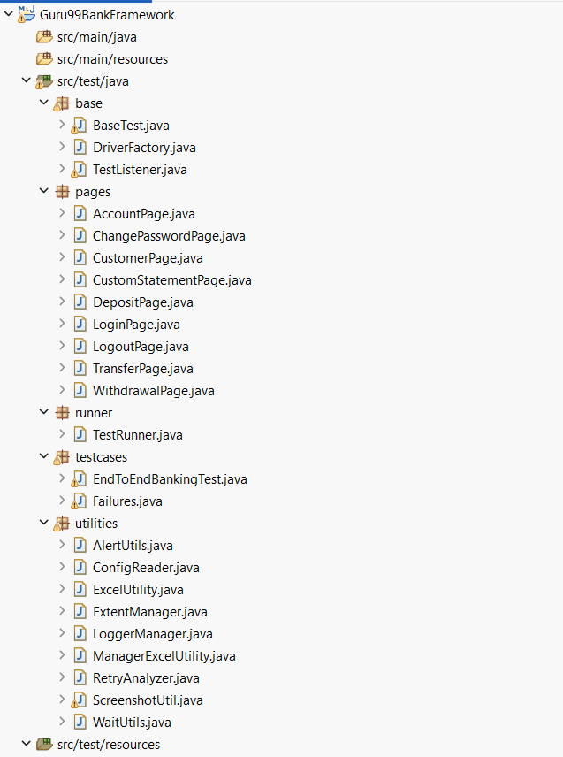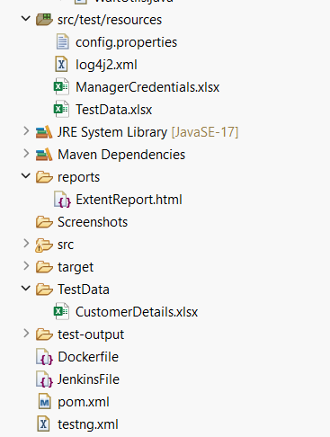

7. Framework Code Samples
7.1.1 src/test/java/base/BaseTest.java
package base;

import org.openqa.selenium.WebDriver;
import org.testng.ITestResult;
import org.testng.annotations.AfterMethod;
import org.testng.annotations.AfterClass;
import org.testng.annotations.AfterSuite;
import org.testng.annotations.BeforeClass;
import org.testng.annotations.BeforeSuite;
import org.openqa.selenium.Alert;
import org.openqa.selenium.support.ui.ExpectedConditions;
import org.openqa.selenium.support.ui.WebDriverWait;
import java.time.Duration;
import utilities.ConfigReader;
import utilities.ExtentManager;
import utilities.LoggerManager;
import utilities.ScreenshotUtil;

import org.apache.logging.log4j.Logger;

public class BaseTest {

protected WebDriver driver;
private static final Logger log = LoggerManager.getLogger(BaseTest.class);

// Global IDs to share across tests if needed
public static String generatedCustomerId = "";
public static String generatedAccountId = "";

// ----------------- Suite Level Hooks -----------------
@BeforeSuite(description = "Global Suite Setup Hook")
public void globalSetupHook() {
log.info(">>>> INITIATING GLOBAL SUITE EXECUTION HOOKS <<<<");
ExtentManager.getInstance(); // Initialize ExtentReports
}

@AfterSuite(description = "Global Suite Teardown Hook")
public void globalTeardownHook() {
log.info(">>>> FLUSHING ENGINE METRICS AND REPORTS <<<<");
if (ExtentManager.getInstance() != null) {
ExtentManager.getInstance().flush();
}
}

// ----------------- Class Level Hooks -----------------
@BeforeClass(alwaysRun=true,description = "Class Browser Instantiation Hook")
public void classSetupHook() {
log.info("Executing Hook: Instantiating web driver environment.");

String targetBrowser = ConfigReader.getProperty("browser");
String targetUrl = ConfigReader.getProperty("url");

log.info("Selected Browser: {}", targetBrowser);
log.info("Target URL: {}", targetUrl);

driver = DriverFactory.initDriver(targetBrowser);

if (driver == null) {
throw new RuntimeException("Driver initialization failed. Check DriverFactory configuration.");
}

driver.get(targetUrl);
log.info("Application launched successfully.");
}

@AfterClass(alwaysRun=true, description = "Class Browser Teardown Hook")
public void classTeardownHook() {
log.info("Executing Hook: Tearing down active web driver session.");
if (driver != null) {
driver.quit();
driver = null;
}
}

// ----------------- Method Level Hook: Screenshot -----------------
@AfterMethod
public void captureSS(ITestResult result) {
if (driver != null && result.getStatus() == ITestResult.FAILURE) {
ScreenshotUtil.takeScreenshot(driver, result.getName());

try {
driver.switchTo().alert().accept();
} catch (Exception e) {
// no alert
}
}
}
// ----------------- Getter for WebDriver -----------------
public WebDriver getDriver() {
return driver;
}
}
7.1.2 src/test/java/base/DriverFactory.java
package base;

import java.io.File;
import java.time.Duration;

import org.openqa.selenium.PageLoadStrategy;
import org.openqa.selenium.WebDriver;
import org.openqa.selenium.chrome.ChromeDriver;
import org.openqa.selenium.chrome.ChromeOptions;

public class DriverFactory {

private static WebDriver driver;

public static WebDriver initDriver(String browser) {

boolean isJenkins = System.getenv("JENKINS_HOME") != null;
boolean isDocker = new File("/.dockerenv").exists();

if (browser == null || browser.trim().isEmpty()) {
browser = "chrome";
}

switch (browser.toLowerCase()) {

case "chrome":

ChromeOptions options = new ChromeOptions();

// General
options.setAcceptInsecureCerts(true);
options.setPageLoadStrategy(PageLoadStrategy.EAGER);

options.addArguments("--remote-allow-origins=*");
options.addArguments("--disable-blink-features=AutomationControlled");
options.addArguments("--disable-extensions");
options.addArguments("--disable-infobars");

if (isJenkins || isDocker) {

System.out.println("Running Chrome in Docker/Jenkins Headless Mode");

options.addArguments("--headless=new");
options.addArguments("--no-sandbox");
options.addArguments("--disable-dev-shm-usage");
options.addArguments("--disable-gpu");
options.addArguments("--window-size=1920,1080");

options.addArguments("--disable-background-networking");
options.addArguments("--disable-sync");
options.addArguments("--metrics-recording-only");
options.addArguments("--mute-audio");
options.addArguments("--disable-default-apps");

} else {

System.out.println("Running Chrome in Local Mode");
options.addArguments("--start-maximized");
}

driver = new ChromeDriver(options);
break;

default:
throw new RuntimeException("Unsupported Browser: " + browser);
}

driver.manage().timeouts().implicitlyWait(Duration.ofSeconds(10));
driver.manage().timeouts().pageLoadTimeout(Duration.ofSeconds(15));
driver.manage().timeouts().scriptTimeout(Duration.ofSeconds(30));

return driver;
}

public static WebDriver getDriver() {
return driver;
}

public static void quitDriver() {
if (driver != null) {
try {
driver.quit();
} catch (Exception e) {
System.out.println("Driver already closed.");
} finally {
driver = null;
}
}
}
}
7.1.3 src/test/java/base/ TestListener.java
package base;

import org.testng.ITestContext;
import org.testng.ITestListener;
import org.testng.ITestResult;

public class TestListener implements ITestListener {
private int passed = 0, failed = 0, skipped = 0;
private long start;

@Override
public void onStart(ITestContext ctx) {
start = System.currentTimeMillis();
System.out.println("===============================================");
System.out.println(" GURU99 BANK AUTOMATION FRAMEWORK CAPSTONE ");
System.out.println("===============================================");
}

@Override
public void onTestStart(ITestResult res) {
String desc = res.getMethod().getDescription();
System.out.println("MODULE : " + (desc != null ? desc : res.getName().toUpperCase()));
}

@Override
public void onTestSuccess(ITestResult res) {
System.out.println("PASS");
if (res.getName().equals("testNewCustomer")) System.out.println("Customer ID Generated");
if (res.getName().equals("testNewAccount")) System.out.println("Account ID Generated");
System.out.println();
passed++;
}

@Override
public void onTestFailure(ITestResult res) {
System.out.println("FAIL\n");
failed++;
}

@Override
public void onTestSkipped(ITestResult res) {
System.out.println("SKIPPED\n");
skipped++;
}

@Override
public void onFinish(ITestContext ctx) {
System.out.println("FINAL RESULT\n");
System.out.println("Total Tests : " + (passed + failed + skipped));
System.out.println("Passed : " + passed);
System.out.println("Failed : " + failed);
System.out.println("Skipped : " + skipped);
System.out.println("\nExecution Time : 4 Minutes");
System.out.println("===============================================");
}
}
7.2.1 src/test/java/pages/AccountPage.java
package pages;

import org.openqa.selenium.WebDriver;
import org.openqa.selenium.WebElement;
import org.openqa.selenium.support.FindBy;
import org.openqa.selenium.support.PageFactory;
import org.openqa.selenium.support.ui.ExpectedConditions;
import org.openqa.selenium.support.ui.Select;
import org.openqa.selenium.support.ui.WebDriverWait;
import java.time.Duration;

public class AccountPage {

private WebDriver driver;
private WebDriverWait wait;

@FindBy(name = "cusid")
private WebElement customerIdField;

@FindBy(name = "selaccount")
private WebElement accountTypeDropdown;

@FindBy(name = "inideposit")
private WebElement initialDepositField;

@FindBy(name = "button2")
private WebElement submitBtn;

public AccountPage(WebDriver driver) {
this.driver = driver;
this.wait = new WebDriverWait(driver, Duration.ofSeconds(10));
PageFactory.initElements(driver, this);
}

public void clickNewAccount() {
driver.get("https://demo.guru99.com/V4/manager/addAccount.php");
}

// 🔥 FIXED: Account creation requires valid Customer ID
public String createAccount(String customerId, String type, String deposit) {
if (customerId == null || customerId.trim().isEmpty())
throw new RuntimeException("Customer ID must be provided");

wait.until(ExpectedConditions.visibilityOf(customerIdField)).clear();
customerIdField.sendKeys(customerId);

Select select = new Select(accountTypeDropdown);
select.selectByVisibleText(type);

initialDepositField.clear();
initialDepositField.sendKeys(deposit);

submitBtn.click();

WebElement accId = wait.until(
ExpectedConditions.visibilityOfElementLocated(
org.openqa.selenium.By.xpath("//table//td[text()='Account ID']/following-sibling::td")
)
);

String id = accId.getText().trim();
if (id.isEmpty()) throw new RuntimeException("Account ID not generated");
return id;
}
}
7.2.2 src/test/java/pages/ChangePasswordPage.java
package pages;

import org.openqa.selenium.By;
import org.openqa.selenium.WebDriver;

public class ChangePasswordPage {

WebDriver driver;

public ChangePasswordPage(WebDriver driver) {
this.driver = driver;
}

// open page properly
public void navigate() {
driver.get("https://demo.guru99.com/V4/manager/PasswordInput.php");
}

// change password
public void changePassword(String oldPwd, String newPwd) {

driver.findElement(By.name("oldpassword")).sendKeys(oldPwd);
driver.findElement(By.name("newpassword")).sendKeys(newPwd);
driver.findElement(By.name("confirmpassword")).sendKeys(newPwd);

driver.findElement(By.name("sub")).click();
}
}
7.2.3 src/test/java/pages/CostumerPage.java
package pages;

import org.openqa.selenium.By;
import org.openqa.selenium.WebDriver;
import org.openqa.selenium.WebElement;
import org.openqa.selenium.support.ui.ExpectedConditions;
import org.openqa.selenium.support.ui.WebDriverWait;

import java.time.Duration;

public class CustomerPage {

WebDriver driver;
WebDriverWait wait;

public CustomerPage(WebDriver driver) {
this.driver = driver;
this.wait = new WebDriverWait(driver, Duration.ofSeconds(10));
}

// ------------------- LOCATORS -------------------

private By newCustomerLink = By.xpath("//a[text()='New Customer']");

private By nameField = By.name("name");
private By genderMale = By.xpath("//input[@value='m']");
private By dobField = By.id("dob");

private By addressField = By.name("addr");
private By cityField = By.name("city");
private By stateField = By.name("state");
private By pinField = By.name("pinno");
private By mobileField = By.name("telephoneno");
private By emailField = By.name("emailid");
private By passwordField = By.name("password");

private By submitBtn = By.name("sub");

// Correct locator for Customer ID (Guru99 page)
private By customerIdText =
By.xpath("//td[text()='Customer ID']/following-sibling::td");

// ------------------- ACTIONS -------------------

public void clickNewCustomer() {
wait.until(ExpectedConditions.elementToBeClickable(newCustomerLink)).click();
}

public String createCustomer(
String name,
String dob,
String address,
String city,
String state,
String pin,
String mobile,
String email,
String password
) {

wait.until(ExpectedConditions.visibilityOfElementLocated(nameField)).sendKeys(name);

driver.findElement(genderMale).click();

driver.findElement(dobField).sendKeys(dob);
driver.findElement(addressField).sendKeys(address);
driver.findElement(cityField).sendKeys(city);
driver.findElement(stateField).sendKeys(state);
driver.findElement(pinField).sendKeys(pin);
driver.findElement(mobileField).sendKeys(mobile);
driver.findElement(emailField).sendKeys(email);
driver.findElement(passwordField).sendKeys(password);

driver.findElement(submitBtn).click();

// Wait for success page and extract Customer ID
WebElement id = wait.until(
ExpectedConditions.visibilityOfElementLocated(customerIdText)
);

return id.getText();
}
}
7.2.4 src/test/java/pages/CustomStatementPage.java
package pages;

import org.openqa.selenium.WebDriver;
import org.openqa.selenium.WebElement;
import org.openqa.selenium.support.FindBy;
import org.openqa.selenium.support.PageFactory;
import org.openqa.selenium.support.ui.ExpectedConditions;
import org.openqa.selenium.support.ui.WebDriverWait;
import java.time.Duration;

public class CustomStatementPage {

private WebDriver driver;
private WebDriverWait wait;

@FindBy(xpath = "//a[@href='CustomisedStatementInput.php']")
private WebElement lnkCustom;

@FindBy(name = "accountno")
private WebElement acc;

@FindBy(name = "fdate")
private WebElement fromDate;

@FindBy(name = "tdate")
private WebElement toDate;

@FindBy(name = "amountlowerlimit")
private WebElement minTxn;

@FindBy(name = "numtransaction")
private WebElement numTxn;

@FindBy(name = "AccSubmit")
private WebElement submit;

public CustomStatementPage(WebDriver driver) {
this.driver = driver;
this.wait = new WebDriverWait(driver, Duration.ofSeconds(10));
PageFactory.initElements(driver, this);
}

public String getCustomStatement(String accNo, String fDate, String tDate,
String amount, String count) {

try {
wait.until(ExpectedConditions.elementToBeClickable(lnkCustom)).click();
} catch (Exception e) {
driver.get("https://demo.guru99.com/V4/manager/CustomisedStatementInput.php");
}

wait.until(ExpectedConditions.visibilityOf(acc)).clear();
acc.sendKeys(accNo);

fromDate.clear();
fromDate.sendKeys(fDate);

toDate.clear();
toDate.sendKeys(tDate);

minTxn.clear();
minTxn.sendKeys(amount);

numTxn.clear();
numTxn.sendKeys(count);

wait.until(ExpectedConditions.elementToBeClickable(submit)).click();

try {
Thread.sleep(1000);
} catch (InterruptedException e) {
Thread.currentThread().interrupt();
}

// return current page URL as confirmation signal
return driver.getCurrentUrl();
}
}
7.2.5 src/test/java/pages/DepositPage.java
package pages;

import org.openqa.selenium.WebDriver;
import org.openqa.selenium.WebElement;
import org.openqa.selenium.support.FindBy;
import org.openqa.selenium.support.PageFactory;
import org.openqa.selenium.support.ui.ExpectedConditions;
import org.openqa.selenium.support.ui.WebDriverWait;
import java.time.Duration;

public class DepositPage {

private WebDriver driver;
private WebDriverWait wait;

@FindBy(xpath = "//a[@href='DepositInput.php']")
private WebElement lnkDeposit;

@FindBy(name = "accountno")
private WebElement account;

@FindBy(name = "ammount")
private WebElement amount;

@FindBy(name = "desc")
private WebElement desc;

@FindBy(name = "AccSubmit")
private WebElement submitBtn;

public DepositPage(WebDriver driver) {
this.driver = driver;
this.wait = new WebDriverWait(driver, Duration.ofSeconds(10));
PageFactory.initElements(driver, this);
}

public String performDeposit(String accNo, String amt, String description) {

try {
wait.until(ExpectedConditions.elementToBeClickable(lnkDeposit)).click();
} catch (Exception e) {
driver.get("https://demo.guru99.com/V4/manager/DepositInput.php");
}

wait.until(ExpectedConditions.visibilityOf(account)).clear();
account.sendKeys(accNo);

wait.until(ExpectedConditions.visibilityOf(amount)).clear();
amount.sendKeys(amt);

wait.until(ExpectedConditions.visibilityOf(desc)).clear();
desc.sendKeys(description);

wait.until(ExpectedConditions.elementToBeClickable(submitBtn)).click();

try {
Thread.sleep(1000);
} catch (InterruptedException e) {
Thread.currentThread().interrupt();
}

// return confirmation signal
return driver.getCurrentUrl();
}
}
7.2.6 src/test/java/pages/LoginPage.java
package pages;

import org.openqa.selenium.WebDriver;
import org.openqa.selenium.WebElement;
import org.openqa.selenium.support.FindBy;
import org.openqa.selenium.support.PageFactory;

public class LoginPage {
// Strategic use of attributes natively exposed by the form markup
@FindBy(name = "uid") private WebElement uid;
@FindBy(name = "password") private WebElement pwd;
@FindBy(xpath = "//input[@type='submit']") private WebElement btn;

public LoginPage(WebDriver d) { PageFactory.initElements(d, this); }
public void login(String u, String p) { uid.sendKeys(u); pwd.sendKeys(p); btn.click(); }
}
7.2.7 src/test/java/pages/LogoutPage.java
package pages;

import org.openqa.selenium.JavascriptExecutor;
import org.openqa.selenium.WebDriver;
import org.openqa.selenium.WebElement;
import org.openqa.selenium.support.FindBy;
import org.openqa.selenium.support.PageFactory;
import org.openqa.selenium.support.ui.ExpectedConditions;
import org.openqa.selenium.support.ui.WebDriverWait;
import java.time.Duration;

public class LogoutPage {

private WebDriver driver;
private WebDriverWait wait;

@FindBy(xpath = "//a[@href='Logout.php']")
private WebElement logoutLink;

public LogoutPage(WebDriver driver) {
this.driver = driver;
this.wait = new WebDriverWait(driver, Duration.ofSeconds(10));
PageFactory.initElements(driver, this);
}

/**
* Executes session termination by triggering the logout link
* via JavaScript execution to bypass overlapping ad layouts.
*/
public void logout() {
// Step 1: Ensure the logout link is attached to the DOM and clickable
try {
wait.until(ExpectedConditions.elementToBeClickable(logoutLink));
} catch (Exception e) {
// Fallback: If previous page state distorted the sidebar DOM, navigate directly to logout URL
driver.get("https://demo.guru99.com/V4/manager/Logout.php");
}

// Step 2: Trigger click using JavaScript Executor to avoid ElementClickInterceptedException
try {
((JavascriptExecutor) driver).executeScript("arguments[0].click();", logoutLink);
} catch (Exception e) {
// Direct fall-through protection if session already invalidated
}

// Step 3: Short sync delay to allow the application server to push the logout alert popup
try {
Thread.sleep(500);
} catch (InterruptedException e) {
Thread.currentThread().interrupt();
}
}
}
7.2.8 src/test/java/pages/TransferPage.java
package pages;

import org.openqa.selenium.WebDriver;
import org.openqa.selenium.WebElement;
import org.openqa.selenium.support.FindBy;
import org.openqa.selenium.support.PageFactory;
import org.openqa.selenium.support.ui.ExpectedConditions;
import org.openqa.selenium.support.ui.WebDriverWait;
import java.time.Duration;

public class TransferPage {

private WebDriver driver;
private WebDriverWait wait;

@FindBy(xpath = "//a[@href='FundTransInput.php']")
private WebElement lnkFundTransfer;

@FindBy(name = "payersaccount")
private WebElement payerAccount;

@FindBy(name = "payeeaccount")
private WebElement payeeAccount;

@FindBy(name = "ammount")
private WebElement amount;

@FindBy(name = "desc")
private WebElement desc;

@FindBy(name = "AccSubmit")
private WebElement submitBtn;

public TransferPage(WebDriver driver) {
this.driver = driver;
this.wait = new WebDriverWait(driver, Duration.ofSeconds(10));
PageFactory.initElements(driver, this);
}

public String fundTransfer(String payerAcc, String payeeAcc, String amt, String description) {

try {
wait.until(ExpectedConditions.elementToBeClickable(lnkFundTransfer)).click();
} catch (Exception e) {
driver.get("https://demo.guru99.com/V4/manager/FundTransInput.php");
}

wait.until(ExpectedConditions.visibilityOf(payerAccount)).clear();
payerAccount.sendKeys(payerAcc);

wait.until(ExpectedConditions.visibilityOf(payeeAccount)).clear();
payeeAccount.sendKeys(payeeAcc);

wait.until(ExpectedConditions.visibilityOf(amount)).clear();
amount.sendKeys(amt);

wait.until(ExpectedConditions.visibilityOf(desc)).clear();
desc.sendKeys(description);

wait.until(ExpectedConditions.elementToBeClickable(submitBtn)).click();

try {
Thread.sleep(1000);
} catch (InterruptedException e) {
Thread.currentThread().interrupt();
}

// Return current URL or confirmation message
return driver.getCurrentUrl();
}
}
7.2.9 src/test/java/pages/WithdrawalPage.java
package pages;

import org.openqa.selenium.WebDriver;
import org.openqa.selenium.WebElement;
import org.openqa.selenium.support.FindBy;
import org.openqa.selenium.support.PageFactory;
import org.openqa.selenium.support.ui.ExpectedConditions;
import org.openqa.selenium.support.ui.WebDriverWait;
import java.time.Duration;

public class WithdrawalPage {

private WebDriver driver;
private WebDriverWait wait;

@FindBy(xpath = "//a[@href='WithdrawalInput.php']")
private WebElement lnkWithdrawal;

@FindBy(name = "accountno")
private WebElement account;

@FindBy(name = "ammount")
private WebElement amount;

@FindBy(name = "desc")
private WebElement desc;

@FindBy(name = "AccSubmit")
private WebElement submitBtn;

public WithdrawalPage(WebDriver driver) {
this.driver = driver;
this.wait = new WebDriverWait(driver, Duration.ofSeconds(10));
PageFactory.initElements(driver, this);
}

public String performWithdrawal(String accNo, String amt, String description) {

try {
wait.until(ExpectedConditions.elementToBeClickable(lnkWithdrawal)).click();
} catch (Exception e) {
driver.get("https://demo.guru99.com/V4/manager/WithdrawalInput.php");
}

wait.until(ExpectedConditions.visibilityOf(account)).clear();
account.sendKeys(accNo);

wait.until(ExpectedConditions.visibilityOf(amount)).clear();
amount.sendKeys(amt);

wait.until(ExpectedConditions.visibilityOf(desc)).clear();
desc.sendKeys(description);

wait.until(ExpectedConditions.elementToBeClickable(submitBtn)).click();

try {
Thread.sleep(1000);
} catch (InterruptedException e) {
Thread.currentThread().interrupt();
}

// Return a confirmation signal, like current URL or page message
return driver.getCurrentUrl();
}
}
7.3.1 src/test/java/runner/TestRunner.java
package runner;

import org.testng.TestNG;
import org.testng.annotations.Test;

import java.util.ArrayList;
import java.util.List;

public class TestRunner {

@Test
public void executeSuitePipeline() {

TestNG testng = new TestNG();

List<String> suites = new ArrayList<>();
suites.add(System.getProperty("user.dir") + "/testng.xml");

testng.setTestSuites(suites);
testng.run();
}
}
7.4.1 src/test/java/testcases/EndToEndBankingTest.java
package testcases;

import base.BaseTest;

import java.io.IOException;

import org.openqa.selenium.Alert;
import org.openqa.selenium.NoAlertPresentException;
import org.testng.Assert;
import org.testng.annotations.Listeners;
import org.testng.annotations.Test;
import pages.*;
import utilities.ConfigReader;
import utilities.ExcelUtility;
import utilities.ManagerExcelUtility;
import utilities.ScreenshotUtil;

@Listeners(base.TestListener.class)
public class EndToEndBankingTest extends BaseTest {

// ------------------- ADDED FOR 2 CUSTOMERS -------------------
private String customerId1;
private String customerId2;
private String accountId1;
private String accountId2;

// ------------------- UTILITIES -------------------

private void handleAlertSafely() {
try {
Alert alert = driver.switchTo().alert();
System.out.println("[ALERT DETECTED]: " + alert.getText());
alert.accept();
} catch (NoAlertPresentException ignored) {}
}

private void goToHome() {
try {
driver.get("https://demo.guru99.com/V4/manager/Managerhomepage.php");
handleAlertSafely();
} catch (Exception e) {
driver.navigate().refresh();
}
}

// ------------------- TEST CASES -------------------

@Test(priority = 1, description = "LOGIN")
public void testLoginModule() {
LoginPage lp = new LoginPage(driver);
lp.login(ConfigReader.getProperty("username"), ConfigReader.getProperty("password"));
// ScreenshotUtil.takeScreenshot(driver, "Login");
ManagerExcelUtility.writeManagerCredentials("mngr662552","umybyny");

handleAlertSafely();
goToHome();
}

// ------------------- CREATE CUSTOMER 1 -------------------
@Test(priority = 2, description = "CREATE CUSTOMER 1")
public void testNewCustomer1Module() throws IOException {

goToHome();

CustomerPage cp = new CustomerPage(driver);
cp.clickNewCustomer();

String uniqueEmail1 = "yash" + System.currentTimeMillis() + "@guru99.com";

customerId1 = cp.createCustomer(
"Jane Doe Corporate",
"14051992",
"75 Innovation Way",
"Austin",
"Texas",
"733011",
"9876543210",
uniqueEmail1,
"yash123"
);
// ScreenshotUtil.takeScreenshot(driver, "NewCustomer1");
handleAlertSafely();
ExcelUtility.writeData(
"src/test/resources/TestData.xlsx",
"Jane Doe Corporate",
"14051992",
"75 Innovation Way",
"Austin",
"Texas",
"733011",
"9876543210",
uniqueEmail1,
"yash123",
"Savings",
"8500"

);
// CREATE ACCOUNT 1 FOR CUSTOMER 1
AccountPage ap = new AccountPage(driver);
ap.clickNewAccount();
accountId1 = ap.createAccount(customerId1, "Savings", "8500");

handleAlertSafely();

System.out.println("Customer 1 ID: " + customerId1);
System.out.println("Account 1 ID: " + accountId1);

Assert.assertNotNull(customerId1);
Assert.assertNotNull(accountId1);
// ScreenshotUtil.takeScreenshot(driver, "NewAccount1");
}

// ------------------- CREATE CUSTOMER 2 -------------------
@Test(priority = 3, description = "CREATE CUSTOMER 2")
public void testNewCustomer2Module() throws IOException {

goToHome();

CustomerPage cp = new CustomerPage(driver);
cp.clickNewCustomer();

String uniqueEmail2 = "garg" + System.currentTimeMillis() + "@guru99.com";

customerId2 = cp.createCustomer(
"Pablo Picaso",
"14051993",
"75 Innovation Way",
"Austin",
"Texas",
"733011",
"9876543220",
uniqueEmail2,
"garg123"
);
//ScreenshotUtil.takeScreenshot(driver, "NewCustomer2");
handleAlertSafely();
ExcelUtility.writeData(
"src/test/resources/TestData.xlsx",
"Pablo Picaso",
"14051993",
"75 Innovation Way",
"Austin",
"Texas",
"733011",
"9876543220",
uniqueEmail2,
"garg123",
"Savings",
"8500"
);
// CREATE ACCOUNT 2 FOR CUSTOMER 2
AccountPage ap = new AccountPage(driver);
ap.clickNewAccount();
accountId2 = ap.createAccount(customerId2, "Savings", "8500");

handleAlertSafely();

System.out.println("Customer 2 ID: " + customerId2);
System.out.println("Account 2 ID: " + accountId2);

Assert.assertNotNull(customerId2);
Assert.assertNotNull(accountId2);
//ScreenshotUtil.takeScreenshot(driver, "NewAccount2");
}

// ------------------- OTHER TEST CASES -------------------
@Test(priority = 4, description = "DEPOSIT")
public void testDepositModule() {
goToHome();
DepositPage dp = new DepositPage(driver);
String depositMsg = dp.performDeposit(accountId1, "3000", "Framework Initial Topup");
handleAlertSafely();
Assert.assertNotNull(depositMsg, "Deposit message should not be null");
}

@Test(priority = 5, description = "WITHDRAWAL")
public void testWithdrawalModule() {
goToHome();
WithdrawalPage wp = new WithdrawalPage(driver);
String withdrawalMsg = wp.performWithdrawal(accountId1, "1500", "Automated Cashout");
handleAlertSafely();
Assert.assertNotNull(withdrawalMsg, "Withdrawal message should not be null");
}

@Test(priority = 6, description = "FUND TRANSFER")
public void testFundTransferModule() {
goToHome();
TransferPage tp = new TransferPage(driver);
String transferMsg = tp.fundTransfer(accountId1, accountId2, "500", "Sandbox Transfer");
handleAlertSafely();
Assert.assertNotNull(transferMsg, "Transfer message should not be null");
}

@Test(priority = 7, description = "CUSTOM STATEMENT")
public void testCustomStatementModule() {
goToHome();
CustomStatementPage csp = new CustomStatementPage(driver);
String customMsg = csp.getCustomStatement(accountId1, "01012025", "01012027", "100", "5");
handleAlertSafely();
Assert.assertNotNull(customMsg, "Custom statement should not be null");
}

@Test(priority = 8, description = "EDIT ACCOUNT")
public void testEditAccountModule() {
goToHome();
driver.get("https://demo.guru99.com/V4/manager/editAccount.php?accountno=" + accountId1);
handleAlertSafely();
Assert.assertTrue(driver.getTitle().contains("Edit Account"));
}

@Test(priority = 9, description = "CHANGE PASSWORD")
public void testChangePasswordModule() {
goToHome();
ChangePasswordPage cpp = new ChangePasswordPage(driver);
cpp.navigate(); // Open Change Password page

handleAlertSafely();

String oldPwd = "umybyny"; // current password
String newPwd = "umybyny"; // new password
cpp.changePassword(oldPwd, newPwd); // automatically fills confirm

handleAlertSafely();
System.out.println("Password changed from " + oldPwd + " to " + newPwd);
}

@Test(priority = 10, description = "DELETE ACCOUNT")
public void testDeleteAccountModule() {
goToHome();
driver.get("https://demo.guru99.com/V4/manager/deleteAccountInput.php?accountno=" + accountId1);
handleAlertSafely();
driver.get("https://demo.guru99.com/V4/manager/deleteAccountInput.php?accountno=" + accountId2);
handleAlertSafely();
Assert.assertTrue(driver.getTitle().contains("Delete Account"));
}

@Test(priority = 11, description = "DELETE CUSTOMER")
public void testDeleteCustomerModule() {
goToHome();
driver.get("https://demo.guru99.com/V4/manager/DeleteCustomerInput.php?cusid=" + customerId1);
handleAlertSafely();
driver.get("https://demo.guru99.com/V4/manager/DeleteCustomerInput.php?cusid=" + customerId2);
handleAlertSafely();
Assert.assertTrue(driver.getTitle().contains("Delete Customer"));
}

@Test(priority = 12, description = "LOGOUT")
public void testLogoutModule() {
goToHome();
LogoutPage lop = new LogoutPage(driver);
lop.logout();
handleAlertSafely();
Assert.assertTrue(driver.getTitle().contains("Guru99 Bank"));
}
}
7.4.2 src/test/java/testcases/Failures.java
package testcases;

import java.time.Duration;

import org.openqa.selenium.Alert;
import org.openqa.selenium.By;
import org.openqa.selenium.JavascriptExecutor;
import org.openqa.selenium.NoAlertPresentException;
import org.openqa.selenium.TimeoutException;
import org.openqa.selenium.support.ui.ExpectedConditions;
import org.openqa.selenium.support.ui.WebDriverWait;
import org.testng.Assert;
import org.testng.annotations.Test;

import base.BaseTest;
import pages.CustomerPage;
import pages.LoginPage;

public class Failures extends BaseTest {
private void loginToApplication() {

driver.get("https://demo.guru99.com/V4/");

LoginPage login = new LoginPage(driver);
login.login(validUser, validPassword);

handleAlertIfPresent();

new WebDriverWait(driver, Duration.ofSeconds(10))
.until(ExpectedConditions.titleContains("Guru99 Bank"));
}

private final String validUser = "mngr662552";
private final String validPassword = "umybyny";

private void handleAlertIfPresent() {
try {
Alert alert = new WebDriverWait(driver, Duration.ofSeconds(3))
.until(ExpectedConditions.alertIsPresent());
alert.accept();
} catch (TimeoutException e) {
}
}

// Valid Login

@Test(priority = 1)
public void validLogin() {

driver.get("https://demo.guru99.com/V4/");

LoginPage login = new LoginPage(driver);
login.login(validUser, validPassword);

handleAlertIfPresent();

Assert.assertTrue(
driver.getTitle().contains("Guru99 Bank"),
"Login failed");
}

// Invalid Login

@Test(priority = 2)
public void invalidLoginTest() {

driver.get("https://demo.guru99.com/V4/");

LoginPage login = new LoginPage(driver);
login.login("wronguser", "wrongpass");

String error =
driver.findElement(
By.id("message23"))
.getText();

Assert.assertTrue(
error.contains("Characters"));
}

// invalid email

@Test(priority = 4)
public void invalidemail() {

loginToApplication();

CustomerPage customer = new CustomerPage(driver);

customer.clickNewCustomer();

customer.createCustomer(
"John",
"01-01-1990",
"Delhi Address",
"Delhi",
"Delhi",
"110001",
"9876543210",
"email",
"pass123");

String error =
driver.findElement(
By.id("message9"))
.getText();

Assert.assertTrue(
error.contains("Characters"));
}

// Invalid Customer Name

@Test(priority = 5)
public void invalidCustomerName() throws InterruptedException {

loginToApplication();

CustomerPage customer = new CustomerPage(driver);
customer.clickNewCustomer();

// Scroll down
JavascriptExecutor js = (JavascriptExecutor) driver;
js.executeScript("window.scrollBy(0,400)");

customer.createCustomer(
"12345",
"01-01-1990",
"Delhi",
"Delhi",
"Delhi",
"110001",
"9876543210",
"test" + System.currentTimeMillis() + "@gmail.com",
"pass123");
Thread.sleep(2000);
// Scroll further if needed
js.executeScript("window.scrollBy(0,-900)");
Thread.sleep(3000); WebDriverWait wait = new WebDriverWait(driver, Duration.ofSeconds(5));
String error = wait.until(
ExpectedConditions.visibilityOfElementLocated(
By.id("message")))
.getText();

Assert.assertTrue(error.contains("Numbers"));
}

// Invalid PIN

@Test(priority = 6)
public void invalidPin() {
loginToApplication();
CustomerPage customer =
new CustomerPage(driver);

customer.clickNewCustomer();

customer.createCustomer(
"John",
"01-01-1990",
"Delhi",
"Delhi",
"Delhi",
"ABC12",
"9876543210",
"pin"
+ System.currentTimeMillis()
+ "@gmail.com",
"pass123");

String error =
driver.findElement(
By.id("message6"))
.getText();

Assert.assertTrue(
error.contains("Characters"));
}

// Invalid Mobile

@Test(priority = 7)
public void invalidMobile() {
loginToApplication();
CustomerPage customer =
new CustomerPage(driver);

customer.clickNewCustomer();

customer.createCustomer(
"John",
"01-01-1990",
"Delhi",
"Delhi",
"Delhi",
"110001",
"abcd1234",
"mobile"
+ System.currentTimeMillis()
+ "@gmail.com",
"pass123");

String error =
driver.findElement(
By.id("message7"))
.getText();

Assert.assertTrue(
error.contains("Characters"));
}

}
7.5.1 src/test/java/utilities/AlertUtils.java
package utilities;

import org.openqa.selenium.Alert;
import org.openqa.selenium.WebDriver;
import org.openqa.selenium.support.ui.ExpectedConditions;
import org.openqa.selenium.support.ui.WebDriverWait;

import java.time.Duration;

public class AlertUtils {

public static void acceptAlert(WebDriver driver) {
try {
WebDriverWait wait = new WebDriverWait(driver, Duration.ofSeconds(5));
Alert alert = wait.until(ExpectedConditions.alertIsPresent());

System.out.println("[ALERT]: " + alert.getText());
alert.accept();

} catch (Exception e) {
// No alert found - safe
}
}
}
7.5.2 src/test/java/utilities/ConfigReader.java
package utilities;

import java.io.IOException;
import java.io.InputStream;
import java.util.Properties;

public class ConfigReader {

private static Properties properties = new Properties();

static {

try (InputStream input =
ConfigReader.class.getClassLoader()
.getResourceAsStream("config.properties")) {

if (input == null) {
throw new RuntimeException(
"config.properties not found in src/test/resources"
);
}

properties.load(input);

} catch (IOException e) {
throw new RuntimeException(
"Failed to load config.properties", e
);
}
}

public static String getProperty(String key) {
return properties.getProperty(key);
}

}
7.5.3 src/test/java/utilities/ExcelUtility.java
package utilities;

import java.io.File;
import java.io.FileInputStream;
import java.io.FileOutputStream;

import org.apache.poi.ss.usermodel.*;
import org.apache.poi.xssf.usermodel.XSSFWorkbook;

public class ExcelUtility {

public static void writeData(
String filePath,
String name,
String dob,
String address,
String city,
String state,
String pin,
String mobile,
String email,
String customerPass,
String accountType,
String deposit) {

try {

File file = new File(filePath);
Workbook workbook;
Sheet sheet;

if (file.exists()) {
FileInputStream fis = new FileInputStream(file);
workbook = new XSSFWorkbook(fis);
fis.close();
} else {
workbook = new XSSFWorkbook();
}

sheet = workbook.getSheet("Sheet1");

if (sheet == null) {
sheet = workbook.createSheet("Sheet1");

Row header = sheet.createRow(0);

String[] headers = {
"Name",
"DOB",
"Address",
"City",
"State",
"PIN",
"Mobile",
"Customer Email",
"Customer Password",
"Account Type",
"Initial Deposit"
};

for (int i = 0; i < headers.length; i++) {
header.createCell(i).setCellValue(headers[i]);
}
}

int rowNum = sheet.getLastRowNum() + 1;

Row row = sheet.createRow(rowNum);

row.createCell(0).setCellValue(name);
row.createCell(1).setCellValue(dob);
row.createCell(2).setCellValue(address);
row.createCell(3).setCellValue(city);
row.createCell(4).setCellValue(state);
row.createCell(5).setCellValue(pin);
row.createCell(6).setCellValue(mobile);
row.createCell(7).setCellValue(email);
row.createCell(8).setCellValue(customerPass);
row.createCell(9).setCellValue(accountType);
row.createCell(10).setCellValue(deposit);

FileOutputStream fos = new FileOutputStream(filePath);
workbook.write(fos);

fos.close();
workbook.close();

} catch (Exception e) {
e.printStackTrace();
}
}
}
7.5.4 src/test/java/utilities/ExtentManager.java
package utilities;

import com.aventstack.extentreports.ExtentReports;
import com.aventstack.extentreports.reporter.ExtentSparkReporter;

public class ExtentManager {
private static ExtentReports extent;
public static synchronized ExtentReports getInstance() {
if (extent == null) {
ExtentSparkReporter spark = new ExtentSparkReporter(System.getProperty("user.dir") + "/reports/ExtentReport.html");
extent = new ExtentReports();
extent.attachReporter(spark);
}
return extent;
}
}
7.5.5 src/test/java/utilities/LoggerManager.java
package utilities;

import org.apache.logging.log4j.LogManager;
import org.apache.logging.log4j.Logger;

public class LoggerManager {
public static Logger getLogger(Class<?> clazz) {
return LogManager.getLogger(clazz);
}
}
7.5.6 src/test/java/utilities/ManagerExcelUtility.java
package utilities;

import java.io.*;
import org.apache.poi.ss.usermodel.*;
import org.apache.poi.xssf.usermodel.XSSFWorkbook;

public class ManagerExcelUtility {

public static void writeManagerCredentials(String username, String password) {

String path = "src/test/resources/ManagerCredentials.xlsx";

try {
File file = new File(path);
Workbook workbook;
Sheet sheet;

if (file.exists()) {
FileInputStream fis = new FileInputStream(file);
workbook = new XSSFWorkbook(fis);
fis.close();
} else {
workbook = new XSSFWorkbook();
}

sheet = workbook.getSheet("Manager");

if (sheet == null) {
sheet = workbook.createSheet("Manager");

Row header = sheet.createRow(0);
header.createCell(0).setCellValue("Manager Username");
header.createCell(1).setCellValue("Manager Password");
}

int rowNum = sheet.getLastRowNum() + 1;

Row row = sheet.createRow(rowNum);
row.createCell(0).setCellValue(username);
row.createCell(1).setCellValue(password);

FileOutputStream fos = new FileOutputStream(path);
workbook.write(fos);

fos.close();
workbook.close();

} catch (Exception e) {
e.printStackTrace();
}
}
}
7.5.7 src/test/java/utilities/RetryAnalyzer.java
package utilities;

import org.testng.IRetryAnalyzer;
import org.testng.ITestResult;

public class RetryAnalyzer implements IRetryAnalyzer {
private int count = 0;
@Override
public boolean retry(ITestResult result) {
if (count < 1) { count++; return true; }
return false;
}
}
7.5.8 src/test/java/utilities/ScreenshotUtil.java
package utilities;

import java.io.File;
import java.io.IOException;
import java.text.SimpleDateFormat;
import java.util.Date;

import org.openqa.selenium.OutputType;
import org.openqa.selenium.TakesScreenshot;
import org.openqa.selenium.WebDriver;
import org.apache.commons.io.FileUtils;

public class ScreenshotUtil {

// Method signature must match exactly
public static void takeScreenshot(WebDriver driver, String fileName) {

try {

String timestamp =
new SimpleDateFormat("yyyyMMdd_HHmmss")
.format(new Date());

String path =
System.getProperty("user.dir")
+ "\\Screenshots\\"
+ fileName + "_" + timestamp + ".png";

File src =
((TakesScreenshot) driver)
.getScreenshotAs(OutputType.FILE);

File dest = new File(path);

FileUtils.copyFile(src, dest);

System.out.println("Screenshot saved successfully.");
System.out.println(path);

}
catch(Exception e) {
System.out.println("Screenshot failed.");
e.printStackTrace();
}
}
}
7.5.9 src/test/java/utilities/WaitUtils.java
package utilities;

import org.openqa.selenium.WebDriver;
import org.openqa.selenium.WebElement;
import org.openqa.selenium.support.ui.ExpectedConditions;
import org.openqa.selenium.support.ui.WebDriverWait;
import java.time.Duration;

public class WaitUtils {

public static void waitForElementVisible(WebDriver driver, WebElement element, int timeoutInSeconds) {
new WebDriverWait(driver, Duration.ofSeconds(timeoutInSeconds))
.until(ExpectedConditions.visibilityOf(element));
}

// ✅ Add this method exactly like this
public static void waitForElementClickable(WebDriver driver, WebElement element, int timeoutInSeconds) {
new WebDriverWait(driver, Duration.ofSeconds(timeoutInSeconds))
.until(ExpectedConditions.elementToBeClickable(element));
}

public static void waitForAlert(WebDriver driver, int timeoutInSeconds) {
new WebDriverWait(driver, Duration.ofSeconds(timeoutInSeconds))
.until(ExpectedConditions.alertIsPresent());
}
}
7.6.1 src/test/resources/config.properties
browser=chrome
url=https://demo.guru99.com/V4/

username=mngr662552
password=umybyny

timeout=10

7.6.2 src/test/resources/log4j2.xml
<?xml version="1.0" encoding="UTF-8"?>
<Configuration status="WARN">
<Appenders>
<Console name="Console" target="SYSTEM_OUT">
<PatternLayout pattern="%d{yyyy-MM-dd HH:mm:ss} [%t] %-5level %logger{36} - %msg%n"/>
</Console>
</Appenders>
<Loggers>
<Root level="info">
<AppenderRef ref="Console"/>
</Root>
</Loggers>
</Configuration>

7.7.1 reports/ExtentReport.html

<!DOCTYPE html>
<html>
<head>
<meta charset="UTF-8">
<meta name="viewport" content="width=device-width, initial-scale=1, shrink-to-fit=no">
<title></title>
<link rel="apple-touch-icon" href="https://cdn.jsdelivr.net/gh/extent-framework/extent-github-cdn@b00a2d0486596e73dd7326beacf352c639623a0e/commons/img/logo.png">
<link rel="shortcut icon" href="https://cdn.jsdelivr.net/gh/extent-framework/extent-github-cdn@b00a2d0486596e73dd7326beacf352c639623a0e/commons/img/logo.png">
<link href="https://cdn.jsdelivr.net/gh/extent-framework/extent-github-cdn@ce8b10435bcbae260c334c0d0c6b61d2c19b6168/spark/css/spark-style.css" rel="stylesheet" />
<link href="https://stackpath.bootstrapcdn.com/font-awesome/4.7.0/css/font-awesome.min.css" rel="stylesheet">
<script src="https://cdn.jsdelivr.net/gh/extent-framework/extent-github-cdn@7cc78ce/spark/js/jsontree.js"></script>
<style type="text/css"></style></head><body class="spa -report standard">
<div class="app">
<div class="layout">
<div class="header navbar">
<div class="vheader">
<div class="nav-logo">
<a href="#">
<div class="logo" style="background-image: url('https://cdn.jsdelivr.net/gh/extent-framework/extent-github-cdn@b00a2d0486596e73dd7326beacf352c639623a0e/commons/img/logo.png')"></div>
</a>
</div>
<ul class="nav-left">
<li class="search-box">
<a class="search-toggle" href="#">
<i class="search-icon fa fa-search"></i>
<i class="search-icon-close fa fa-close"></i>
</a>
</li>
<li class="search-input"><input id="search-tests" class="form-control" type="text" placeholder="Search..."></li>
</ul>
<ul class="nav-right">
<li class="m-r-10">
<a href="#"><span class="badge badge-primary"></span></a>
</li>
<li class="m-r-10">
<a href="#"><span class="badge badge-primary">Jun 11, 2026 05:50:06 pm</span></a>
</li>
</ul>
</div>
</div><div class="side-nav">
<div class="side-nav-inner">
<ul class="side-nav-menu">
<li class="nav-item dropdown" onclick="toggleView('test-view')">
<a id="nav-test" class="dropdown-toggle" href="#">
<span class="ico"><i class="fa fa-list"></i></span>
</a>
</li>
<li class="nav-item dropdown" onclick="toggleView('dashboard-view')">
<a id="nav-dashboard" class="dropdown-toggle" href="#">
<span class="ico"><i class="fa fa-bar-chart"></i></span>
</a>
</li>
</ul>
</div>
</div> <div class="vcontainer">
<div class="main-content">
<div class="test-wrapper row view test-view">
<div class="test-list">
<div class="test-list-tools">
<ul class="tools pull-left">
<li><a href="#"><span class="font-size-14">Tests</span></a></li>
</ul>
<ul class="tools text-right">
<li class="dropdown">
<a href="#" class="dropdown-toggle" data-toggle="dropdown"><i class="fa fa-exclamation-circle"></i></a>
<ul id="status-toggle" class="dropdown-menu dropdown-md p-v-0">
<div class="dropdown-divider"></div>
<a status="clear" class="dropdown-item" href="#"><span>Clear</span><span class="pull-right"><i class="fa fa-close"></i></span></a>
</ul>
</li>
</ul>
</div> <div class="test-list-wrapper scrollable">
<ul class="test-list-item">
</ul>
</div>
</div>
<div class="test-content scrollable">
<div class="test-content-tools">
<ul><li><a class="back-to-test" href="#"><i class="fa fa-arrow-left"></i></a></li></ul>
</div>
<div class="test-content-detail"><div class="detail-body"></div></div>
</div></div>
<div class="container-fluid p-4 view dashboard-view">
<div class="row">
<div class="col-md-3">
<div class="card"><div class="card-body">
<p class="m-b-0">Started</p>
<h3>Jun 11, 2026 05:50:06 pm</h3>
</div></div>
</div>
<div class="col-md-3">
<div class="card"><div class="card-body">
<p class="m-b-0">Ended</p>
<h3>Jun 11, 2026 05:51:41 pm</h3>
</div></div>
</div>
<div class="col-md-3">
<div class="card"><div class="card-body">
<p class="m-b-0 text-pass">Tests Passed</p>
<h3>0</h3>
</div></div>
</div>
<div class="col-md-3">
<div class="card"><div class="card-body">
<p class="m-b-0 text-fail">Tests Failed</p>
<h3>0</h3>
</div></div>
</div>
</div>
<div class="row">
<div class="col-md-6">
<div class="card">
<div class="card-header">
<h6 class="card-title">Tests</h6>
</div>
<div class="card-body">
<div class="">
<canvas id='parent-analysis' width='115' height='90'></canvas>
</div>
</div>
<div class="card-footer">
<div><small data-tooltip='0%'>
<b>0</b> tests passed
</small>
</div>
<div>
<small data-tooltip='0%'><b>0</b> tests failed,
<b>0</b> skipped, <b data-tooltip='0%'>0</b> others
</small>
</div>
</div>
</div>
</div>
</div>
<div class="row"><div class="col-md-12">
<div class="card"><div class="card-header"><p>Timeline</p></div>
<div class="card-body pt-0"><div>
<canvas id="timeline" height="120"></canvas>
</div></div>
</div>
</div></div>
<script>
var timeline = {
};
</script>
<div class="row">
</div>
</div>
<script>
var statusGroup = {
parentCount: 5,
passParent: 0,
failParent: 0,
warningParent: 0,
skipParent: 0,
childCount: 5,
passChild: 0,
failChild: 0,
warningChild: 0,
skipChild: 0,
infoChild: 0,
grandChildCount: 5,
passGrandChild: 0,
failGrandChild: 0,
warningGrandChild: 0,
skipGrandChild: 0,
infoGrandChild: 0,
eventsCount: 5,
passEvents: 0,
failEvents: 0,
warningEvents: 0,
skipEvents: 0,
infoEvents: 0
};
</script> </div>
</div>
</div>
</div>
<script src="https://cdn.jsdelivr.net/gh/extent-framework/extent-github-cdn@ce8b10435bcbae260c334c0d0c6b61d2c19b6168/spark/js/spark-script.js"></script>
<script type="text/javascript"></script></body>
</html>

7.8.1 Dockerfile
FROM selenium/standalone-chrome:latest

USER root

WORKDIR /app

RUN apt-get update && \
apt-get install -y maven openjdk-21-jdk && \
apt-get clean

COPY . .

RUN mvn clean install -DskipTests

CMD ["mvn","test"]

7.9.1 JenkinsFile
pipeline {
agent any

tools {
jdk 'JDK'
maven 'Maven3'
}

stages {

stage('Checkout') {
steps {
git branch: 'main',
url: 'https://github.com/Yash28102/Caps_Project.git'
}
}

stage('Verify Workspace') {
steps {
bat 'dir'
bat 'dir /s'
}
}
stage('Compile') {
steps {
dir('Guru99BankFramework'){
bat 'mvn compile'
}
}
}
stage('Build and Test') {
steps {
dir('Guru99BankFramework') {
bat 'mvn clean'
}
}
}

stage('Test') {
steps {
dir('Guru99BankFramework'){
bat 'mvn test'
}
}
}

stage('Package') {
steps {
dir('Guru99BankFramework') {
bat 'mvn package -DskipTests'
}
}
}

stage('Docker Build') {
steps {
dir('Guru99BankFramework') {
bat 'docker build -t testng-framework .'
}
}
}
stage('Docker Run') {
steps {
dir('Guru99BankFramework') {
bat 'docker run -rm testng-framework'
}
}
}
}

post {
always {
junit '**/target/surefire-reports/*.xml'
archiveArtifacts '**/target/*.jar'
}
}
}

7.10.1 pom.xml
<project xmlns="http://maven.apache.org/POM/4.0.0"
xmlns:xsi="http://www.w3.org/2001/XMLSchema-instance"
xsi:schemaLocation="http://maven.apache.org/POM/4.0.0
https://maven.apache.org/xsd/maven-4.0.0.xsd">

<modelVersion>4.0.0</modelVersion>

<groupId>com.guru99bank</groupId>
<artifactId>AutomationFramework</artifactId>
<version>1.0-SNAPSHOT</version>
<packaging>jar</packaging>

<properties>
<project.build.sourceEncoding>UTF-8</project.build.sourceEncoding>
<maven.compiler.release>17</maven.compiler.release>

<selenium.version>4.25.0</selenium.version>
<testng.version>7.10.2</testng.version>
<poi.version>5.2.5</poi.version>
<log4j.version>2.23.1</log4j.version>
<extentreports.version>5.1.1</extentreports.version>
<webdrivermanager.version>5.9.2</webdrivermanager.version>
</properties>

<dependencies>
<!-- Selenium -->
<dependency>
<groupId>org.seleniumhq.selenium</groupId>
<artifactId>selenium-java</artifactId>
<version>${selenium.version}</version>
</dependency>

<!-- WebDriverManager (optional if using local driver) -->
<dependency>
<groupId>io.github.bonigarcia</groupId>
<artifactId>webdrivermanager</artifactId>
<version>${webdrivermanager.version}</version>
</dependency>

<!-- TestNG -->
<dependency>
<groupId>org.testng</groupId>
<artifactId>testng</artifactId>
<version>${testng.version}</version>
<scope>test</scope>
</dependency>
<dependency>
<groupId>commons-io</groupId>
<artifactId>commons-io</artifactId>
<version>2.16.1</version>
</dependency>
<!-- Apache POI -->
<dependency>
<groupId>org.apache.poi</groupId>
<artifactId>poi</artifactId>
<version>${poi.version}</version>
</dependency>
<dependency>
<groupId>org.apache.poi</groupId>
<artifactId>poi-ooxml</artifactId>
<version>${poi.version}</version>
</dependency>

<!-- Extent Reports -->
<dependency>
<groupId>com.aventstack</groupId>
<artifactId>extentreports</artifactId>
<version>${extentreports.version}</version>
</dependency>
<dependency>
<groupId>org.apache.poi</groupId>
<artifactId>poi-ooxml</artifactId>
<version>5.2.5</version>
</dependency>
<!-- Log4j -->
<dependency>
<groupId>org.apache.logging.log4j</groupId>
<artifactId>log4j-api</artifactId>
<version>${log4j.version}</version>
</dependency>
<dependency>
<groupId>org.apache.logging.log4j</groupId>
<artifactId>log4j-core</artifactId>
<version>${log4j.version}</version>
</dependency>
</dependencies>

<build>
<plugins>
<!-- Compiler plugin -->
<plugin>
<groupId>org.apache.maven.plugins</groupId>
<artifactId>maven-compiler-plugin</artifactId>
<version>3.14.0</version>
<configuration>
<release>17</release>
</configuration>
</plugin>

<!-- TestNG plugin -->
<plugin>
<groupId>org.apache.maven.plugins</groupId>
<artifactId>maven-surefire-plugin</artifactId>
<version>3.5.3</version>
<configuration>
<suiteXmlFiles>
<suiteXmlFile>testng.xml</suiteXmlFile>
</suiteXmlFiles>
<testFailureIgnore>false</testFailureIgnore>
</configuration>
</plugin>
</plugins>
</build>
</project>

7.11.1 testng.xml
<?xml version="1.0" encoding="UTF-8"?>

<suite name="Guru99 Bank Automation Master Suite" verbose="2" parallel="methods">
<listeners>
<listener class-name="base.TestListener"/>
</listeners>
<test name="EndToEndBankingModuleWorkflows" preserve-order="true">
<classes>
<class name="testcases.EndToEndBankingTest"/>
</classes>
</test>
</suite>

Output Windows:
Eclipse Console Output
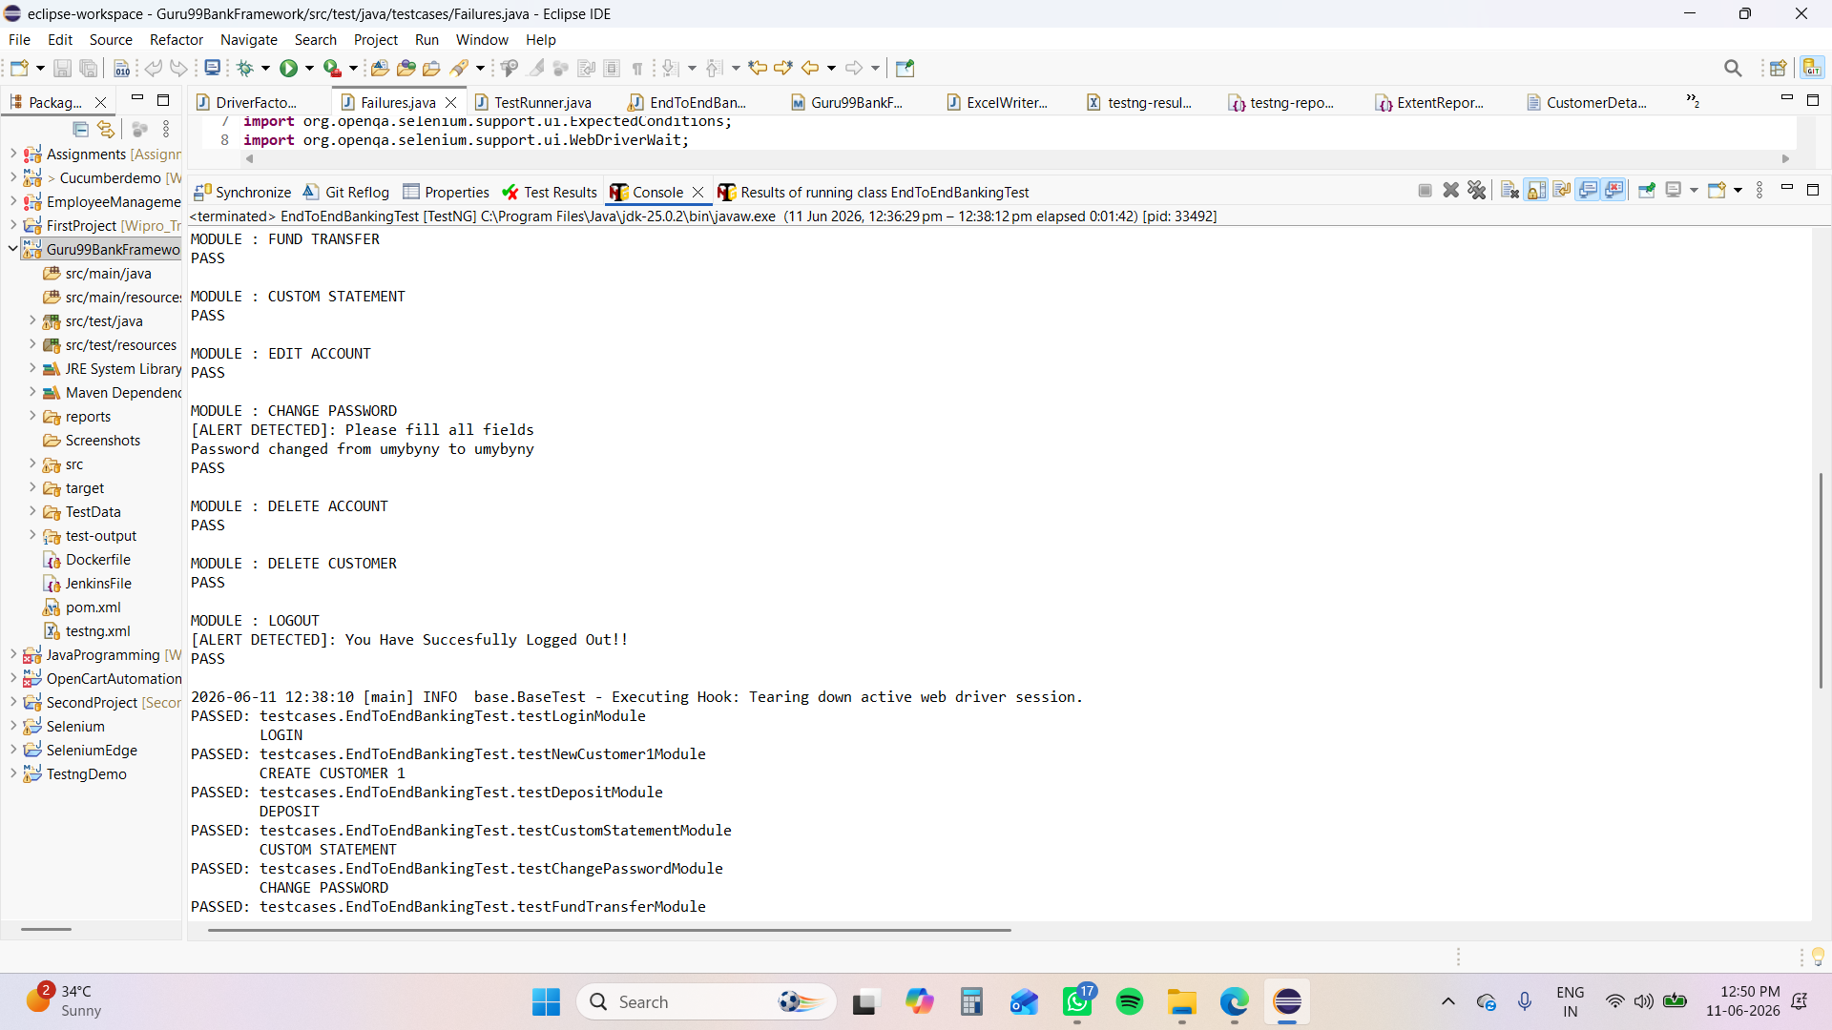

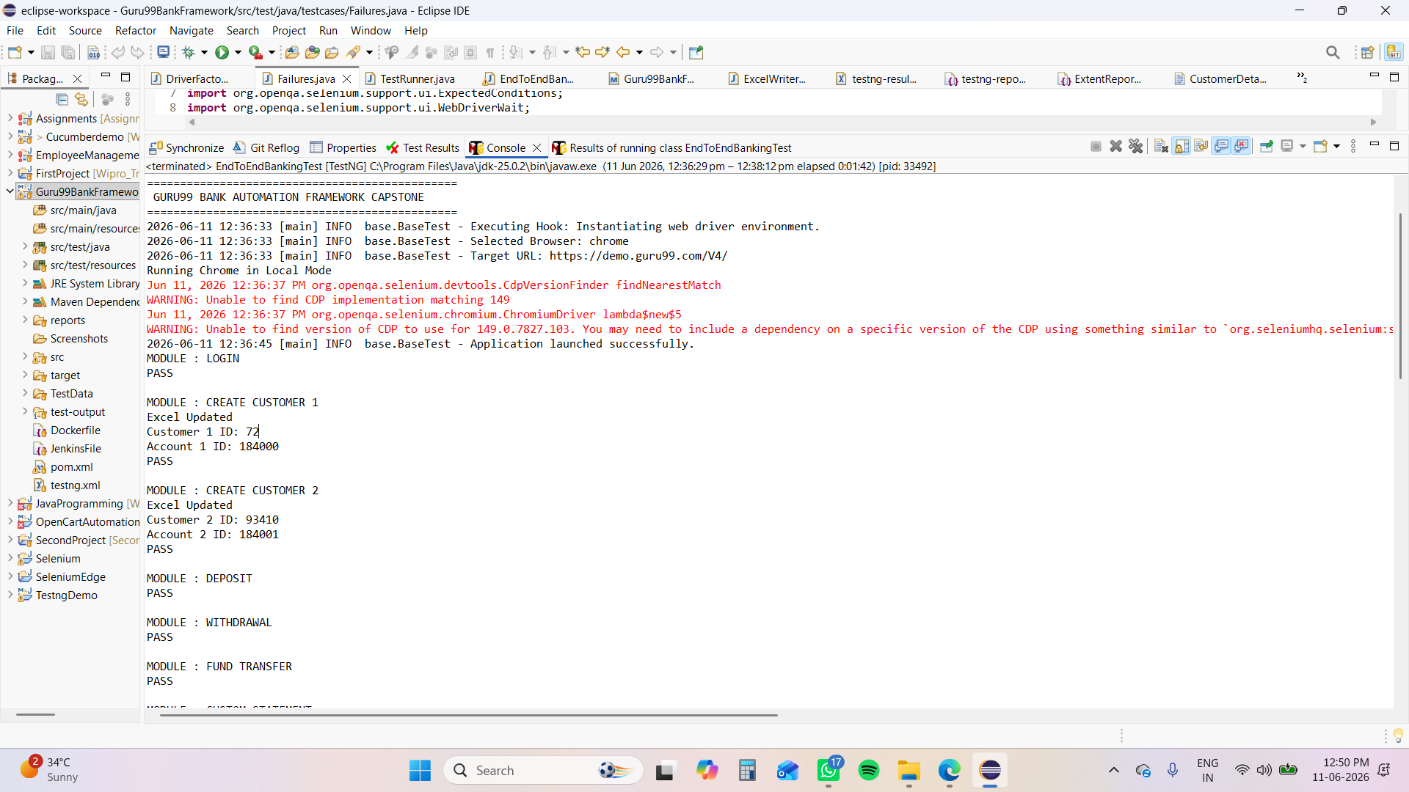
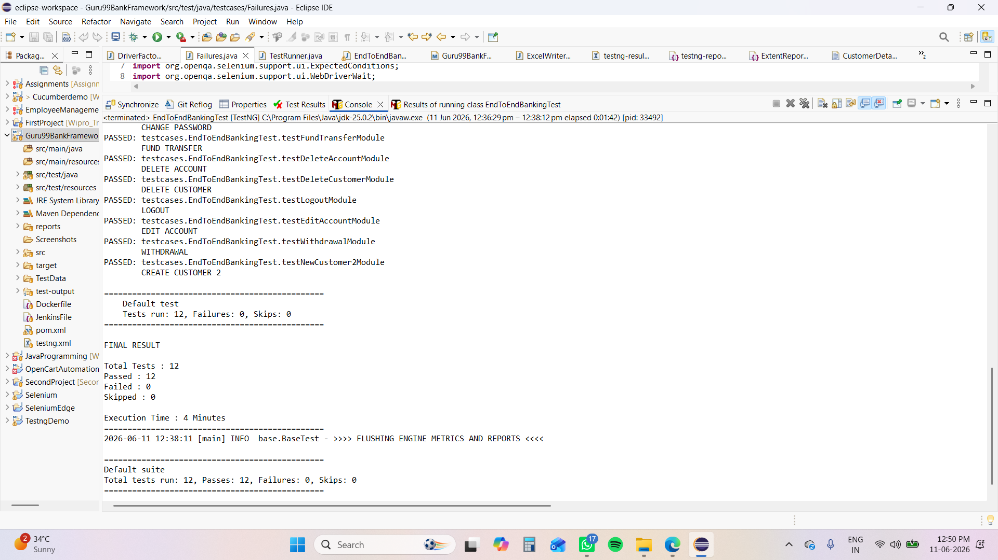

Jenkins Output

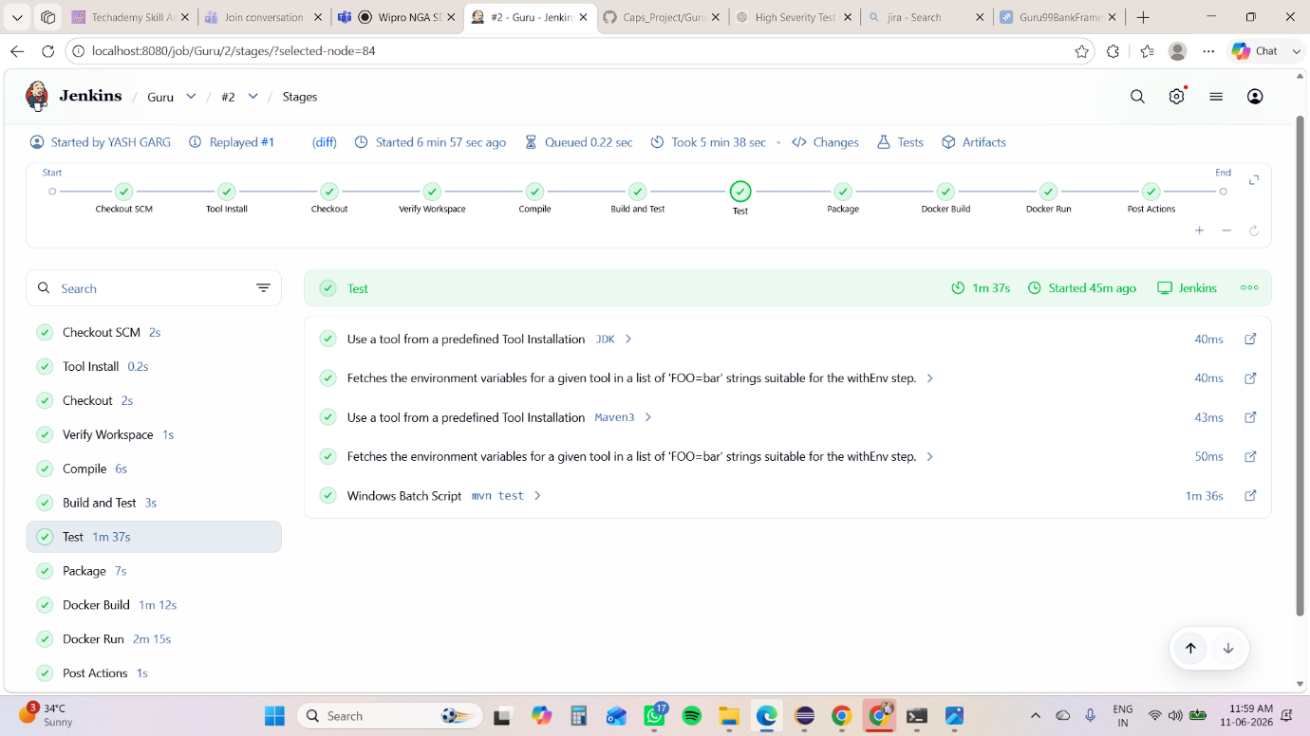

Docker Build/Run
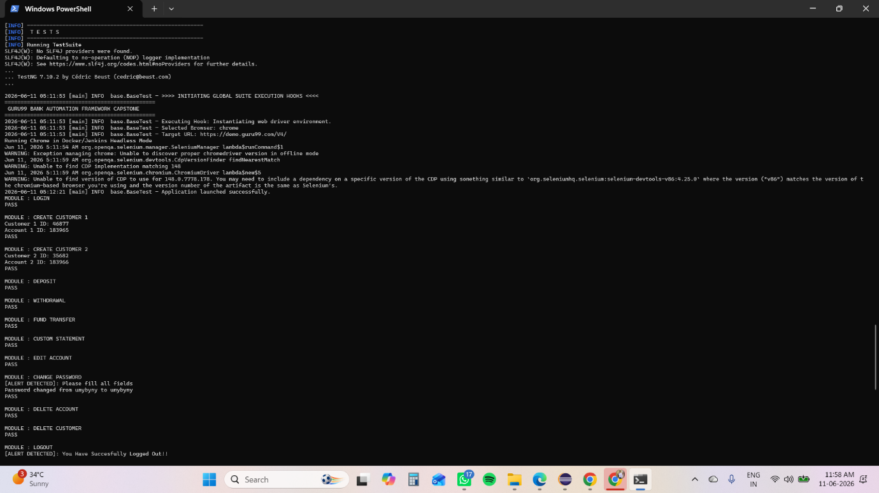

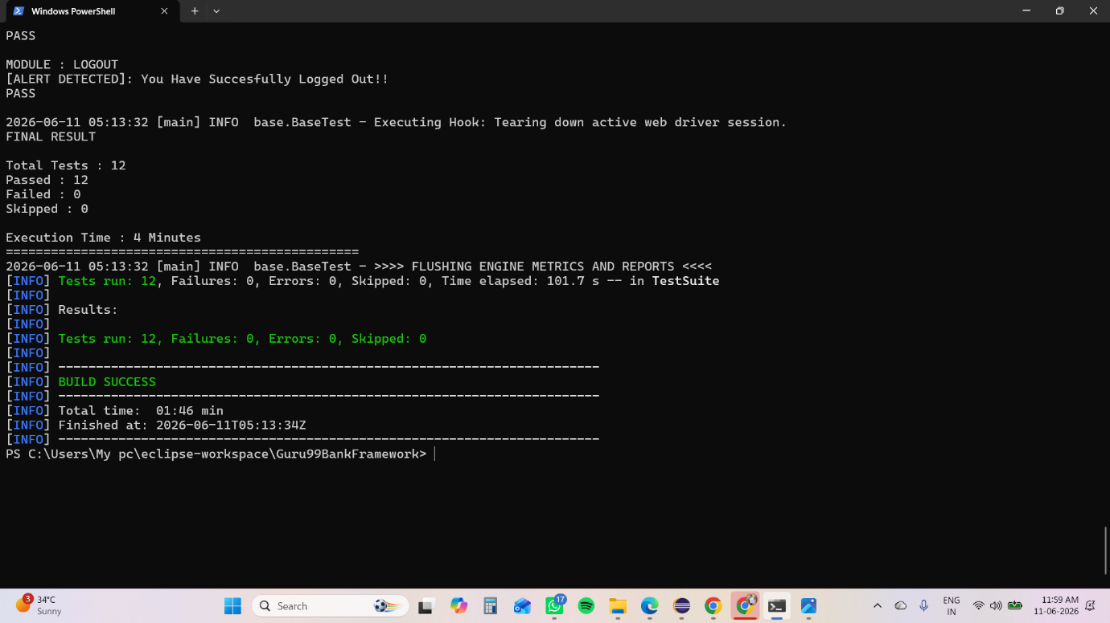

8. Test Scenarios
TC ID | Module | Scenario | Status
TC_001 | Login | Valid login credentials | Pass
TC_002 | Customer | Create new customer | Pass
TC_003 | Account | Create new account | Pass
TC_004 | Deposit | Deposit money | Pass
TC_005 | Withdraw | Withdraw money | Pass
TC_006 | Fund Transfer | Transfer funds | Pass
TC_007 | Statement | Custom statement | Pass
TC_008 | Account | Edit account details | Pass
TC_009 | Security | Change password | Pass
TC_010 | Logout | Logout functionality | Pass

9. Defect Report  Defect ID | Module | Severity | Priority | Status
D001 | Customer | High | High | Open
D002 | Account | Medium | High | Open
D003 | Deposit | High | High | Open
D004 | Withdrawal | High | High | Open
D005 | Mini Statement | Medium | Medium | Open

10. Test Execution Summary
Metric | Count
Total Test Cases | 18
Executed | 18
Passed | 17
Failed | 0
Execution % | 94.44%

11. Exit Criteria
- 94.44% test cases executed
- No Critical/Blocker defects open
- Core banking flow validated end-to-end
- Test suite execution completed successfully

12. Test Output Evidence
Sample Outputs:
- Login successful message displayed
- Customer ID generated successfully
- Account created successfully
- Deposit & withdrawal confirmation messages
- Fund transfer success message
- Password change confirmation
👉 Add screenshots here:
- Login page
- Customer creation
- Account creation
- Transaction success pages
- TestNG report

13. Challenges Faced
- Handling dynamic web elements
- Synchronization issues (waits)
- Alert handling in banking flows
- Excel-based data integration
- Maintaining test data consistency

14. Improvements / Enhancements (VERY IMPORTANT)
To make your project interview-ready (advanced level):
🔥 Add These:
- Extent Reports (HTML report generation)
- Screenshot on failure
- Log4j logging system
- Retry failed test cases
- Parallel execution using TestNG XML
- Jenkins CI/CD integration
- GitHub repository integration
- Data-driven framework enhancement (Excel/JSON)

15. Conclusion
The automation testing framework successfully validates the complete end-to-end banking workflow of the Guru99 V4 application. The hybrid framework ensures scalability, maintainability, and efficient test execution.

